TEMPLATE 2: PRODUCT REQUIREMENTS DOCUMENT

Company Name:
PART 1:
- Describe the primary use cases (real-world applications) of your solution. Include both actual and potential use cases. Please share any data or results from pilot implementations. For each actual and potential use case, explain why your technology is well-suited for that application.

 | Use case 1  (Real-world application) | Use case 2 | Use case 3
Brief Description
(200 characters limit)
Actual or Potential
Has the tech component of your solution been prototyped and tested? If yes, please summarise the components prototyped and test results:
(200 characters limit)
Why is the technology suitable for this use case:
(200 characters limit)

PART 2:

Please choose the most relevant technology category (ies) for your solution and complete questions on either

A) Software
B) Content

*Make sure all relevant components are covered. You can provide answers in one or two categories.
*Note that the questions for start-ups using data and/or blockchain in section (A) Software should only be answered if relevant to your solution.

SECTION A: SOFTWARE

- Prototyping: Describe the work you have done on proofs of concept, mockups, and user testing. List the last three versions of your solution’s design. For each version, please provide 2 sentences that describe the reasons for the changes (including data) and outline the main changes made.

Version | Main characteristics and features | Main changes from the previous version | Reasons for changes made  (Including data collected/ feedback received/ refined understanding of user needs):
Version 1
Version 2
Version 3

- Before you developed your own technology or selected an existing one, what other similar technologies did you consider using, improving or iterating to solve the problem you want to solve? (Outline what other technologies were considered to address the problem you identified and why were they rejected as unsuitable).

 | Technology description (200 characters limit) | Unsuitable because: (500 characters limit)
1
2
3
4

- Please choose the type of license that applies to your solution:
- Copyleft (e.g., GNU General Public License)
- Permissive (e.g., MIT License, Apache License)
- Uncertain of Category, but an OSI-Approved License
- Not Open Source yet
- Other (please specify)

- If currently not an Open Source license solution, are you willing to release your tech solution under an Open Source license (https://opensource.org/licenses/) (please refer to the Funding Agreement to consider the obligations for Open Source licensing and investment by the Venture Fund):
☐ Yes
☐ No

- Please insert at the end of this template (Annex 1) a diagram of your current tech stack including all components and subsystems, showing their linkages and interactions. A tech stack is a combination of software products and programming languages used. For this diagram, include both client-side and server-side documentation, if relevant, tools used for front-end and back-end systems (including databases), and any meta-layers. If you are using machine learning, please describe your pipeline.

Please find here two examples of tech stacks that you can use as templates:

- 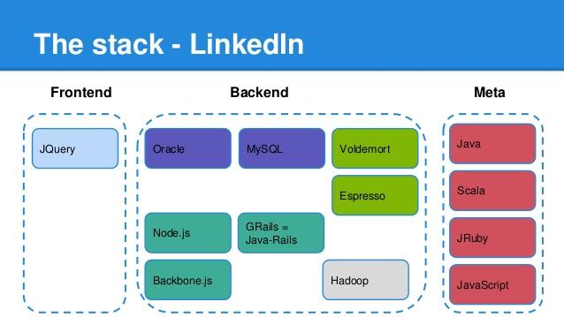

- 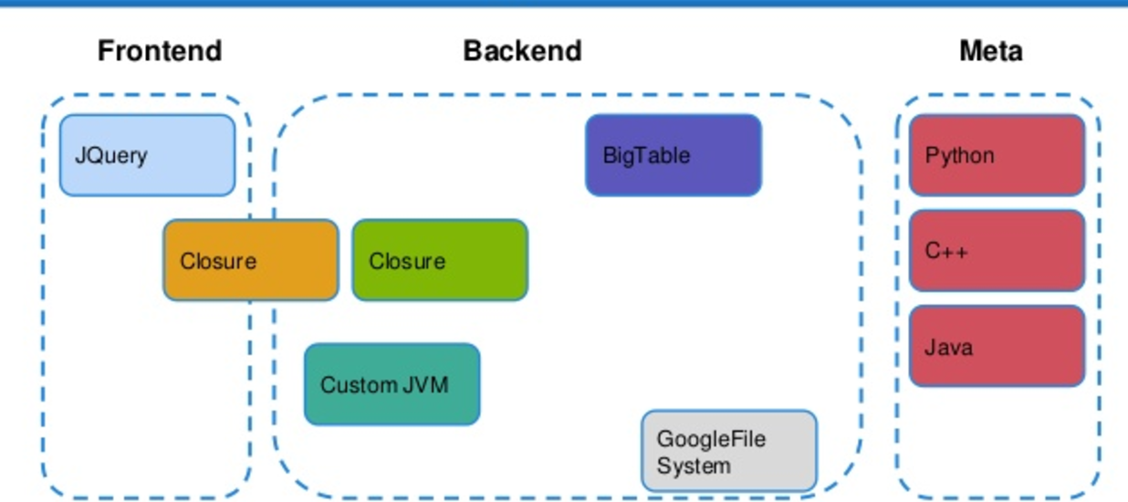

Additionally, please provide written documentation explaining the diagram provided, outlining each element included in the diagram, its role and its status of development (complete, under development, expected date of completion, etc). Please clarify if these components are currently Open Source or proprietary, and in the case of the latter if you intend to release it as Open Source solution. Include links or documents outlining process documentation, system documentation, user documentation, and any instructions on API usage, if relevant. (5,000 characters limit)

- Which repository hosting service/git forge do you use for your solution:
  - GitHub
  - GitLab
  - Gitea
  - Other (please specify):

- Share here all GitHub / Bitbucket (or other) repositories for all components of your solution: (1,000 characters limit)

If your repositories are private, and on Github, GitLab or Bitbucket; please make sure to give access to our user before you send this form back to us: @unicefinnovation or venturefund@unicef.org (we assure you that the information in your repositories will only be used to evaluate funding your solution and will not be shared).

- Please share the GitHub, GitLab or bitbucket (or other) handles of the code developers within your team:

- How many external contributors have there been to your code?

- What processes and tools do you leverage for quality assurance and testing? (1,000 characters limit)

- If you are not using git version control system, what are you using? Please specify (200 characters limit)

- Sustainability: What is the ongoing plan for maintenance, updates, and support of your software? Describe what the needs will be for the next two years and how these will be met. (1,000 characters limit)

- If your start-up is using data as a central part of the solution:

  - Describe the scope of the data that you are processing. Specifically:

- What data elements are you processing (i.e., collecting, using, retaining, sharing, etc.) to provide your product/service? Describe: (1,000 characters limit)

- Do you collect any personally identifiable data, and/or children’s data? If so, how are you collecting, processing and storing this information? Please provide any details on data management policies, agreements, or practices being followed or planned. (1,000 characters limit)

- How much data will you be collecting and using? How often will you be collecting data (is it a one-time collection or on an ongoing basis)? Describe your processes: (1,000 characters limit)

  - Describe how you already collect or plan to collect data. Please provide a data flow diagram (1,000 characters limit).

- If your start-up is using classical machine learning (i.e. not Generative AI) in the proposed solution (ML):
  - Describe your intended models and the rationale for selecting them. Explain how you balance model sophistication with constraints (e.g., data availability, computational resources, and interpretability needs, etc.) (1,000 characters limit).

  - Describe your model evaluation metrics (e.g., accuracy, F1, recall, AUC) and explain why they're appropriate for your solution. How will you monitor performance and detect performance decline? What is your roadmap for improvement, retraining, and handling data drift or changing requirements? (1,000 characters limit)

  - Describe the limitations of your methodology: Where does your approach fail? (e.g. your predictions are biased because you do not have enough data for a certain class) (1,000 characters limit)

  - Describe your approach to ensuring training data diversity and fairness. How do you ensure that your model's training data is (i) diverse and representative of your target population, (ii) how do you measure fairness in your model, including performance testing disaggregated by relevant demographic or population groups (iii) what method do you use to identify performance disparities, measure that your model promotes fairness and avoids discriminatory outcomes? (1,000 characters limit).

- If your startup is using Artificial Intelligence (AI), Generative AI or Agentic AI:

  - Are you implementing or planning to implement LLMs? If so, please explain why the chosen model is appropriate for your solution and context? Whether you will conduct any additional training, fine-tuning, or distillation, and how this will be done. Whether any of the models are open-weight models or not. (1,000 characters limit).

  - Do you plan to evaluate your models or methods? Please describe your evaluation metrics and approach. Consider factors such as accuracy metrics (e.g. BLEU/ROUGE/METEOR, perplexity, faithfulness), task-specific performance (e.g. RAGAS metrics; tool-use accuracy), safety and alignment (e.g. toxicity, refusal rates, bias benchmarks), and performance efficiency (e.g. latency, cost per query). If you consider other factors, explain the metrics and approach (1,000 characters limit).

  - Do you have a plan for model iteration, cost management, and resource optimization? Please address: 1) whether and how you will update or swap models as technology and costs evolve, 2) how you will monitor token usage and inference costs, and 3) whether your solution can function in low-resource or low-bandwidth settings or on device.

  - Describe the limitations of your methodology and approach. Where does your solution underperform or fail? Address your understanding of the different forms of bias that may be exhibited by your application (e.g., data bias from underrepresented classes, model bias, demographic bias, etc.) and how you plan to identify and mitigate them. Additionally, are there any ethical considerations that affect your approach?

  - Describe how you evaluate your application for algorithmic bias and fairness. 1) Do you have a monitoring and evaluation process? What does it assess? 2) How do you test for group fairness (i.e., performance equality, demographic parity across groups)? 3) What methods do you use to identify and mitigate discriminatory outcomes? (1,000 characters limit).

  - If you plan to use an existing Generative AI model, please describe the novel component and differentiated approach you will implement. Examples can include but are not limited to model distillation for resource-constrained settings, fine-tuning on domain-specific data, multilingual data collection, or custom evaluation frameworks. (1,000 characters limit).

- If your start-up is using blockchain:

  - What blockchain platform(s) are you using? (i.e. Bitcoin, Ethereum, Hyperledger, etc). Please explain your choice and clarify whether it is a private or public chain (1,000 characters limit).

  - Is your product deployed? If so, where? Describe (i.e. private node, mainnet, test net) (1,000 characters limit).

  - What language are you using to create your smart contracts? (i.e. Solidity, Lvy, Viper) (1,000 characters limit).

  - How do you test your smart contracts? (1,000 characters limit).

  - Is personal/biometric data being stored in the blockchain? If yes, how are you ensuring the privacy of that data? (1,000 characters limit).

  - Are elements of your solution subject to regulatory scrutiny or compliance requirements (e.g. VASP license, money transmitter license, KYC/AML etc.)? (1,000 characters limit).

  - If you are subject to regulatory scrutiny, do you possess the required licenses and permissions to deploy your solution? (500 characters limit).

    - Please provide proof of possession of the above licenses/permissions

    - Please provide links to official government sources which point to the latest on this subject from your country

  - If you are subject to compliance requirements, please provide proof of compliance or a plan to become compliant (1000 characters limit).

  - Please explain how a user can connect and interact with the blockchain of your solution (e.g. through non-custodial wallets, through an email based privy integration, through a web2 user interface with username and password but with wallet abstracted by the back end etc.) (1000 character limit)

SECTION B: CONTENT (leave blank, if no content-related components to your project)

- Please provide an overview of the new content you have created or are planning to create. Provide a description that includes but is not limited to: subject, audience, language, format, medium. (1,000 characters limit).

- Who else is developing similar or identical content? How is your new content different from the existing one? What is the gap you are attempting to address? (1,000 characters limit)

- List the learning objectives you are planning to meet through the content (1,000 characters limit).

- Please insert on the last page of this template (Annex 3), a content/curriculum map diagram (max 1 page), including the general organization of the content, rough relational hierarchy. Please clarify if any these components are currently open source or proprietary, and in the case of the latter if you intend to release them as open content. Be sure to give details at the lowest level of granularity of your content.

- Please provide a sample of the content you have created (at the end of this template Annex 4) and/or plan to create (copy/paste at the end of this form in the appropriate place). The sample should cover one piece, i.e. one video, one pdf, one set of exercises etc.

- Provide a short explanation that shows how this sample relates to the overall content. Describe the context of the example content within your larger set of content (1,000 characters limit).

- Please describe how the content will be delivered to the user (face-to-face facilitation, self-paced, etc). (1,000 characters limit)

- Please explain where the content will be hosted and how the user will access the content (LMS, CMS, etc.) (1,000 characters limit)

- Provide the number of content objects (including the breakdown of media types) …
a) ...currently offer:
-audio (e.g. mp3)
-video (e.g. mp4)
-rich text (pdf, html, other markup language)
-pure HTML5 frontend apps (embeddable in iframe)

b) propose to create:
-audio (e.g. mp3)
-video (e.g. mp4)
-rich text (pdf, html, other markup language)
-pure HTML5 frontend apps (embeddable in iframe)

- Please select the license type that your content is registered under.
☐ CC-BY
☐ CC-BY-SA
☐ CC-BY-NC
☐ CC-BY-ND
☐ CC-BY-NC-SA
☐ CC-BY-NC-ND
☐ Other equivalent (please specify):
☐ Not currently on an open source license

- If currently not on an open content, are you willing to release your content under a CC-BY or CC-BY-SA or equivalent open content license (please refer to the Funding Agreement to consider the obligations for open source licensing and investment by the Innovation Fund):
☐ Yes
☐ No
- Sustainability: How will content be updated based on user needs, feedback and data collected? (1,000 characters limit)

ANNEX 1: SECTION A. QUESTION 5
PLEASE INSERT HERE: Annex 1: a diagram of your current tech stack including all components and subsystems, showing their linkages and interactions. A tech stack is a combination of software products and programming languages used. For this diagram, include: both client-side and server side documentation if relevant, tools used for front-end and back-end systems (including databases), and any meta-layers.

ANNEX 3: SECTION C. QUESTION 4
PLEASE INSERT HERE: Annex 3: a content/curriculum map diagram (max 1 page), including the general organization of the content, rough relational hierarchy. Be sure to give details at the lowest level of granularity of your content.

ANNEX 4: SECTION C. QUESTION 5
PLEASE INSERT HERE: Annex 4: a sample of the content you have created (at the end of this template Annex 4) and/or plan to create (copy/paste at the end of this form in the appropriate place). The sample should cover one piece, i.e. one video, one pdf, one set of exercises etc.

